wearables manager 2

By matew

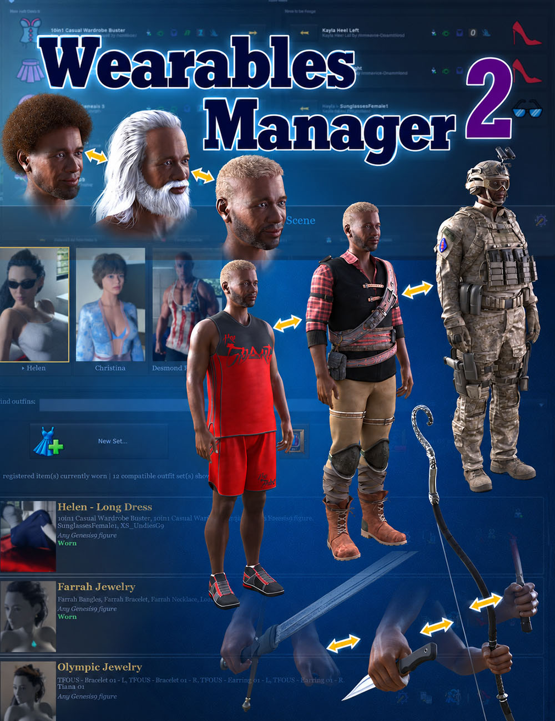
Contents
What’s NEW in Wearables manager 2
Wearables Manager Take OFF
Wearables Manager PUT ON
Wearables Manager MENU
Wearables Manager FULL
Wearables Manager Icon Rules
Wearables Manager Supported figures
Wearables Manager Wardrobe
Figure Panel
Outfit Panel
Register All Matches
Create and Edit Outfits
Available For
Using Specific Figure Sets in Other Scenes
Bind to Another Figure
Set Icon
Set Properties
Outfit Items
Wardrobe
Individual transition rules
Take Off All
Settings
Set Maintenance
Material Backup Cache
Technical Script for Developers
Known issues
Hello, dear Artist! Thank you for purchasing Matew's Wearables Manager 2. The first version of this product focused entirely on improving productivity in DAZ Studio. Temporarily removing clothing, hair, and other assets that were not needed at the time made the figure much more responsive and easier to control. With the lag gone, posing and animating a character became much faster and more enjoyable.
Wearables Manager 2 goes much further. It still includes the same scripts, now improved, but it also offers a complete wardrobe system that is easy to manage and can be configured for an individual character or an entire group. You can quickly switch outfits, apply associated morphs such as Fiber Micropressure, save hand poses, handle geografts correctly, transfer them between characters, and much more.

What’s NEW in Wearables manager 2

1. Interface and Compatibility
- Support for DAZ Studio 4 and DAZ Studio 6.
- Redesigned settings windows, outfit editor, source selection, and partial outfit application.
- Improved labels, tooltips, long-name display, and button states.
- Clearer separation between cancelling a transfer and undoing individual actions.
- Compatibility with legacy icon filenames and existing user settings.

2. New Wardrobe Module — Outfit Library
- Create, save, edit, and duplicate outfits.
- Register individual items for reuse across multiple outfits.
- Organize outfits into groups and filter them by compatibility with the selected figure.
- Apply complete outfits or select individual items and saved properties.
- Define outfit transitions: keep, remove, or replace specific items.
- Choose whether to load an item from the library or transfer an existing instance from another figure.
- Save variants of composite items with attached child objects.
- Save and restore item and figure properties, as well as materials.
- Identify currently worn and modified outfits.
- Copy libraries with integrity verification.

3. Custom Icon Rules Editor
- Assign icons to your wardrobe items.
- Six matching modes: exact matches or whole-word matches in an item’s name, label, or Asset ID.
- Reorder rules to control their priority.
- Import custom PNG icons.

4. Configurable Figure Support
- Dedicated Supported Figures editor.
- Add custom figure types. Wearables Manager 2 will continue working with Genesis 10 or Genesis 9.1 or whatever.

5. Integration Between Wearables Manager and Wardrobe
- Outfit membership badges in Menu and Full.
- Tooltips listing the outfits that contain an item in the active library.

6. More Reliable Clothing Removal and Restoration
- Improved object identification, reducing reliance on duplicate or changed names.
- Stronger validation of parenting, Fit To, and collision relationships.
- Improved recovery and rollback of incomplete operations.
- Persistent storage for shell recovery backups.
- Fixes for transferring fitted clothing between figures with different scales.
- Fixes for validation after resetting source outfit properties.

7. Performance Improvements
- Faster Menu startup, clothing removal, and restoration in complex scene hierarchies.
- Optimized Wardrobe catalog reading, filtering, and outfit card creation.

 | Wearables Manager Take OFF  one-click removal of all items from your figure

The Wearables Manager Take Off script detaches all items parented to the current character and stores them in a new group labeled Character’s Name Belongings. Feel free to rename, reparent, or perform other actions without worry – it does not sever the connection between the Storage Group and your character.
Essential items attached to basic figures by default, such as eyelashes for Genesis 8 or eyes and mouth for Genesis 9, will not be detached.
If you set in the Wearables Manager Menu which items to retain, only the specified items will be moved to the Storage Group (see more details below.)
Additionally, you can delete some unnecessary items from the storage folder more conveniently. No need to play Hide & Seek with such assets as piercing or jewelry.

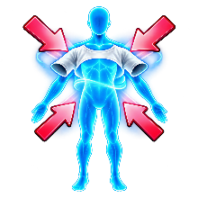 | Wearables Manager PUT ON  restores everything in one click

This script returns all items from the Storage Group to your figure in their original state and restores geoshell materials if necessary.
It will only return items to their original owner, regardless of how many figures are present in the scene. Once items are restored, the Storage Group is removed.
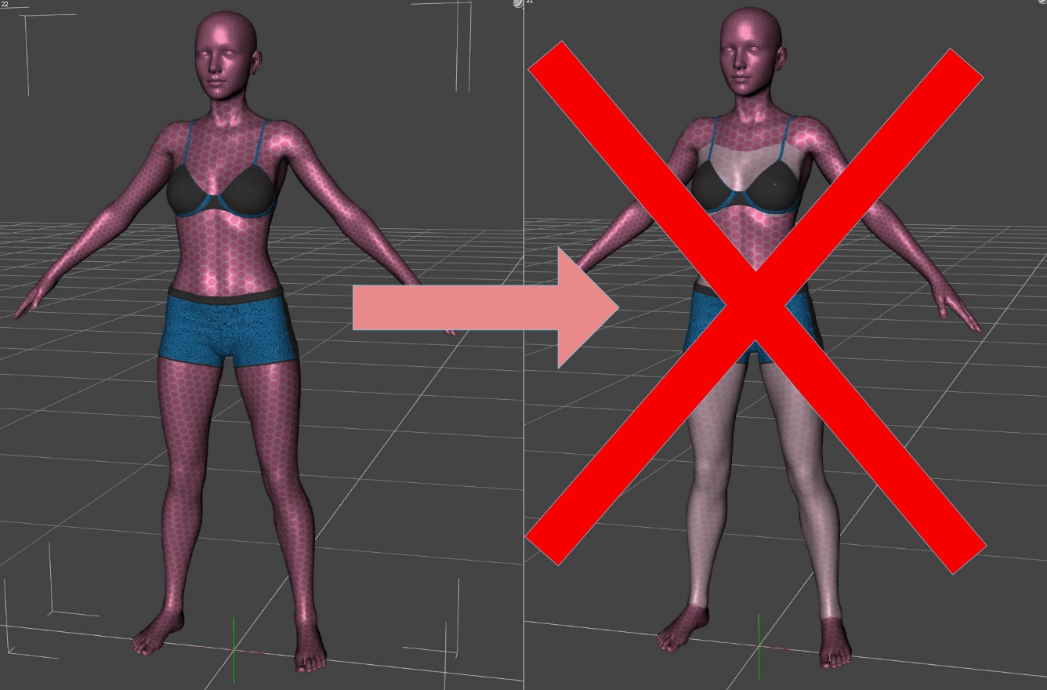
Wearables Manager efficiently handles geografts and geoshells, preventing the loss of material information that typically results in white surfaces, as shown in the right image. Geografts are assets that expand the initial geometry of figures, enhancing detail and creating new surfaces. When you have multiple geografts, unparenting any of them can inevitably lead to the loss of material information created for those geografts. DAZ 3D deletes these materials immediately to prevent memory leakage.
However, it is advisable not to separate geografts and geoshells from each other. If some are attached to the figure while others are detached and located in the Storage Group, a situation may arise where it becomes impossible to preserve information. In such cases, Wearables Manager will revert the changes, returning all items back to your figure to ensure stability and integrity.
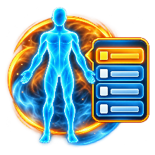 | Wearables Manager MENU  Advanced management of wearables
This interface allows you to select items for transfer and adjust critical parameters from a single screen. Here's an overview of the functionalities:
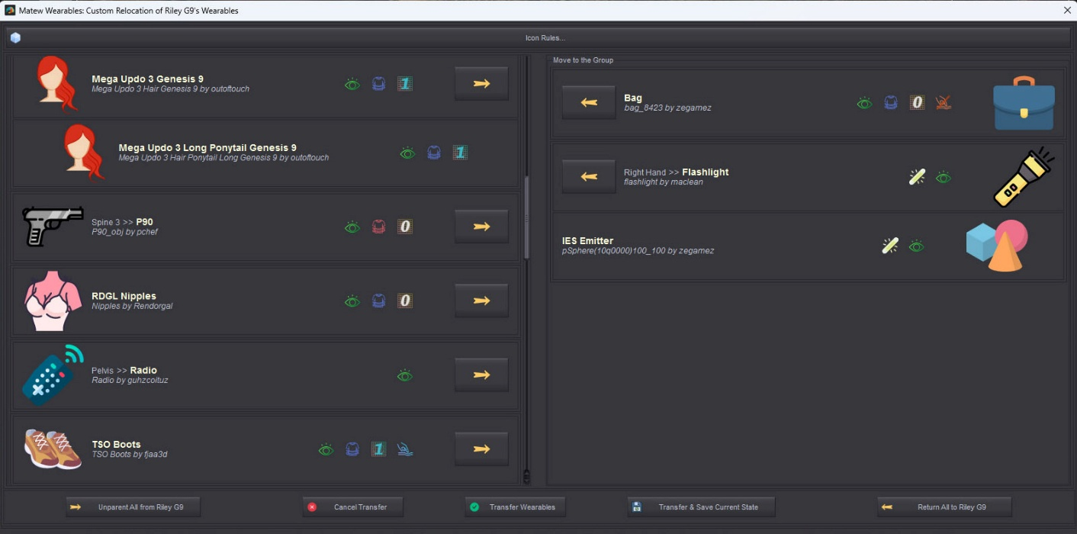
Button | Function
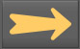 | Unparents an item from your figure and transfers it to the Storage Group.
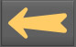 | Returns an item from the Storage Group back to your figure.
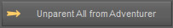 | Unparents all the items from your figure and transfers them to the Storage Group.
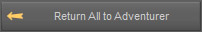 | Returns all the items from the Storage Group back to your figure.
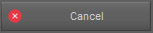 | Closes the Menu without transferring items.
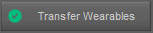 | Executes the transfer of selected items.
Executes the transfer of selected items and saves the current state. After saving, Wearables Manager Take Off Script will take off only the items that are currently moving to the Storage Group (shown on the right side).
To reset it, move all items to the right and repeat this action.
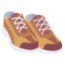,,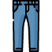… | Clicking on any item selects it on the Scene Viewer Panel.  Hold Shift to select a several items.
Green sign shows that the item has an active dForce modifier.
Blue crossed sign means that Freeze Simulation is On.
Red crossed sign means that the item has a dForce modifier, but it’s not active now. Hover over the sign to find out the reason.
Left click on the sign toggles Freeze Simulation On / Off.
Shift + Click jumps to the Freeze Simulation property on the Parameters Panel.
Yellow sign shows that the item has an emissive surface(s).
Grey sign means that the item has turned off emissive surface(s).
Half yellow sign shows the item has several emissive surfaces. Some of them are turned on, and some are turned off. Hover over the sign to find out the details.
Click on the sign toggles emissive surface(s) On / Off.
Shift + Click selects all emissive surfaces on Surfaces Panel.
Ctrl + Click allows to pick up emissives you want to turn On / Off.
Blue sign means that the item fits to the current figure.
Purple sign means that it fits to something else. Hover over the sign to find out the details.
Red sign means that the figure fits to none.
Click on the sign to jump to Fit To property on the Parameters Panel.
Shows if the light is On or Off.
Click toggles the current light On / Off.
Shift + Click jumps to the light properties on the Parameter Panel.
Green sign means that the item is visible.
Red sign means that the item is invisible.
Yellow sign means that the item is invisible either in Viewport or in render. Hover over the sign to find out the details.
Click toggles Show / Hide the item.
Shift + Click jumps to the Display properties on the Parameters Panel.
Ctrl + Click allows to set the visibility On / Off in Viewport and / or in render.
Blue sign means that the item has a Smooth Modifier and collides with the current figure.
Blue sign with yellow > means that the item has a Smooth Modifier and collides with another figure. Hover over the sign to find out the details.
Blue sign with a red cross means that the item has a Smooth Modifier and collides with nothing.
Half red waiving line means that an Interactive Update is On. It may significantly decrease the responsiveness of the system.
Red crossed sign means that the Smooth Modifier is Off.
Hower over the sign for the details.
Click toggles the Smooth Modifier On / Off.
Shift + Click jumps to the Mesh Smoothing properties on the Parameters Panel.
Yellow Zero, One, and Two Plus appear if the item is converted into SubD and show its View SubD Level, which is equal to the minimum Render SubD Level.
Gray Zero means that the item is not converted into SubD.
Click on the Gray Zero sign converts item into SubD and sets its SubD to one.
Click on other signs toggles the item’s SubD level 0-1-2-0.
Shift + Click jumps to the Mesh Resolution properties on the Parameters Panel.
 | This item belongs to at least one outfit. Hover over the icon for details.
 | Icon Rules. Opens the Icon Rules script to customize item icons (see below).

 | Wearables Manager FULL  All-in-one script with extended capabilities

This comprehensive script combines all other scripts' functionalities and offers additional features depending on the modifier key used during interaction:
Combination | Outcome
Click | Activates Wearables Manager Take Off script.
Shift + Click | Activates Wearables Manager Put On script.
Ctrl + Click | Launches the advanced Wearables Manager Menu.
Alt + Click | Removes all wearables, including default items.
Ctrl + Alt + Click | Launches the advanced menu with default items included.

This script perfectly fits for placing on the Toolbox. To do that, please follow this instruction:
- Right-click on Wearables Manager Full and choose Create Custom Action;
- Navigate to Menu Window → Workspace → Customize (or press F3).
- Locate Wearables Manager Full in the Actions section, typically at the end of the Custom.
- In the Activities section on the right side of the screen, ensure your desired Toolbar is active.
- Go to the Tool Bars tab and drag Wearables Manager Full to your preferred location.

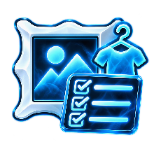 | Wearables Manager Icon Rules  Customize icons for your wearables
This interface allows you to select items for transfer and adjust critical parameters from a single screen. Here's an overview of the functionalities:
This script lets you define custom rules for displaying item icons in Wearables Manager Menu.
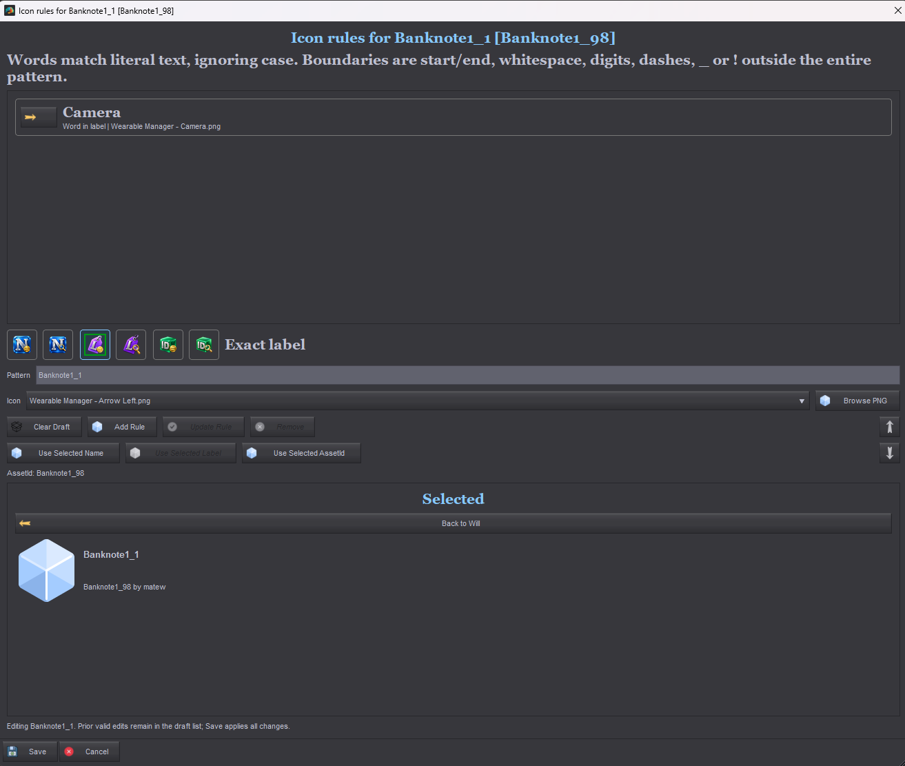
The top of the dialog shows your existing custom rules. You can edit, delete, and reorder them. The rule with the longest matching pattern takes priority. If two patterns have the same length, the rule higher in the list takes priority.
The six buttons below let you choose how a rule matches an item:
Button | Action
 | Assign an icon to all items with the specified name.
 | Assign an icon to all items whose name contains the specified whole word.
 | Assign an icon to all items with the specified label.
 | Assign an icon to all items whose label contains the specified whole word.
 | Assign an icon to all items with the specified Asset ID.
 | Assign an icon to all items whose Asset ID contains the specified whole word.

- Choose an icon from the standard icon library or load your own. Standard icons are 91 x 91 px.
- Clear Draft clears the latest changes so you can configure the rule again.
- Add Rule, Update Rule, and Remove create a new rule, update the current rule, or delete it, respectively.
- Use Selected Name, Use Selected Label, and Use Selected Asset ID copy the corresponding property of the selected item into the pattern field.
- The bottom of the dialog contains the item selector and rule preview.

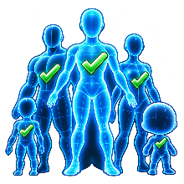 | Wearables Manager Supported figures  Add and configure supported figures

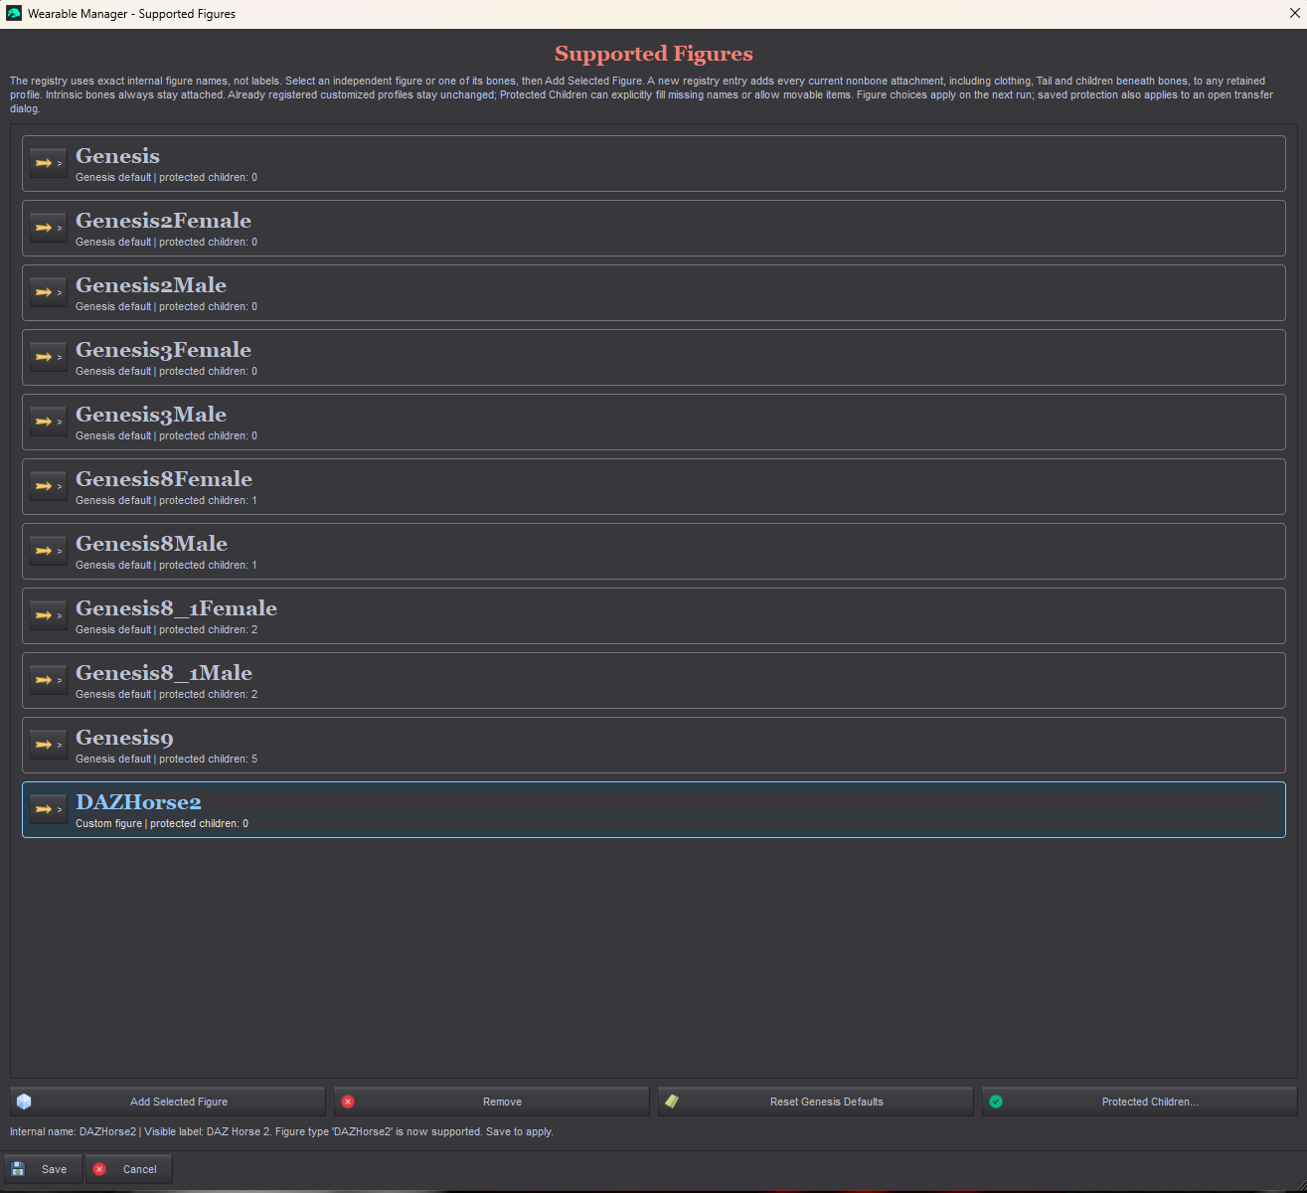
By default, Wearables Manager supports all generations of Genesis human figures, from Genesis through Genesis 9. This script lets you configure support for other figures, such as horses, dogs, and other creatures that are not based on Genesis, as well as future generations of Genesis figures.
This script also opens when you run Wearables Manager Put On, Wearables Manager Take Off, Wearables Manager Menu, or Wearables Manager Full with an unsupported figure selected.
To add a new figure type, select the figure in the scene, then run Wearables Manager Supported Figures.
To remove a figure type from the supported list, select it and click Remove.
Click Reset Genesis Defaults to restore the default set of supported figures.
Protected Children are nodes parented to the figure that should remain attached when you use Wearables Manager Take Off and should not appear in Wearables Manager Menu. Examples include the eyelashes or mouth of a Genesis 9 figure.
To add protected children for a figure you have added, select those child nodes in the scene, run the script, click Protected Children, and choose Add Selected Children in the dialog that opens.
You can also remove protected children in this dialog.

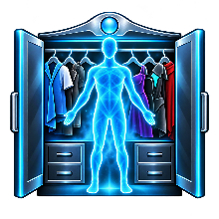 | Wearables Manager Wardrobe  Manage your characters’ wardrobes
- Create outfits containing clothing, hair, jewelry, piercings, handheld tools, and other items.
- Outfits can also include morphs for their items and for the character itself, such as Fiber Micropressure.
- Create outfits for all Genesis figures of a particular type or for one specific character.
- The script handles geografts and geoshells while preserving their materials correctly.
- Wearables Manager Wardrobe can switch materials when the same item appears in different outfits with different materials.
- Switch outfits with one click or apply only selected parts. Transfer them to another character or create a separate copy, organize them into groups, and apply morphs and hand poses.
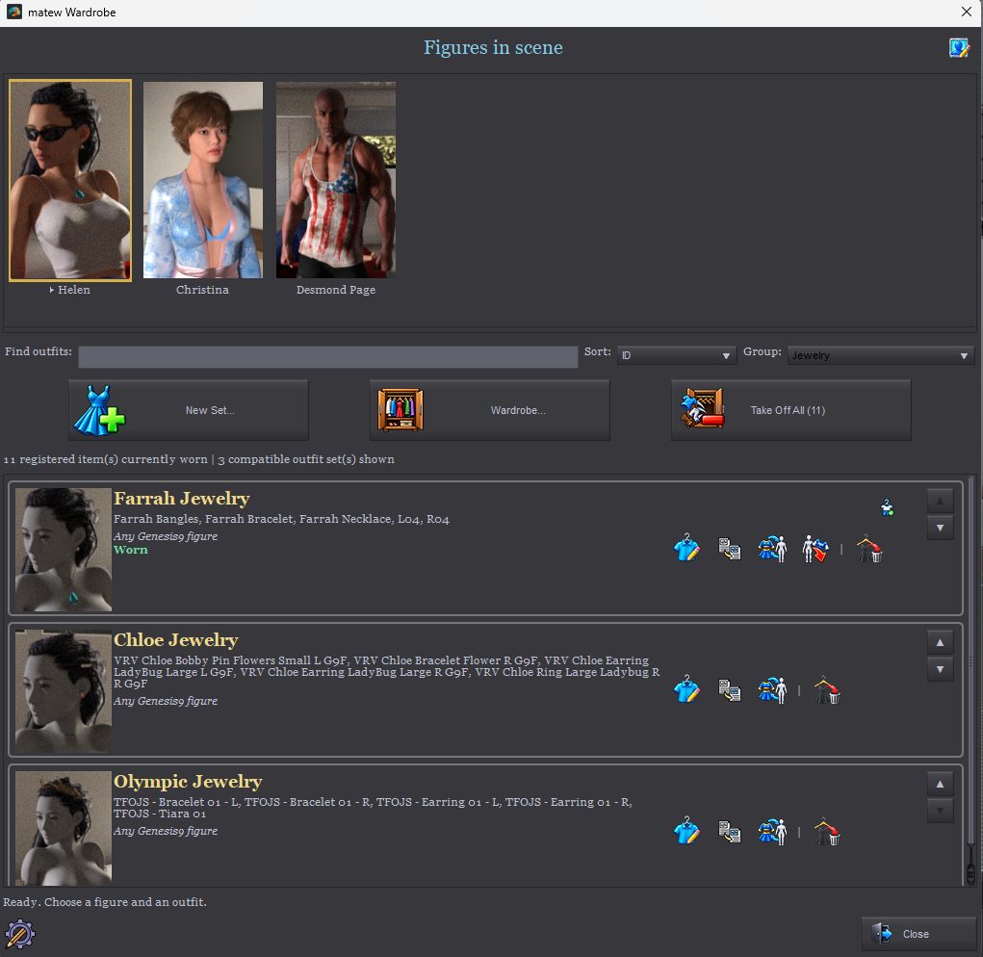

Figure Panel
The top panel shows all characters in the scene. Select a character to display its compatible outfits below. Until you assign a custom icon to a character, the script displays an icon based on its Genesis generation.
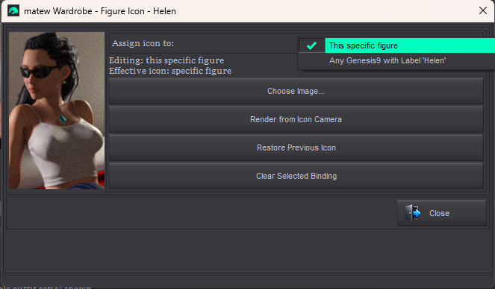
The icon in the upper-right corner opens the Figure Icon dialog. You can assign an icon to a specific figure or to figures with the same label.
This specific figure – assigns the icon only to this particular figure. Save the figure as a Scene Subset to use it in other scenes while allowing Wardrobe to continue recognizing it correctly.
Any Genesis X with current label – identifies the figure by its label. Change the label to make Wardrobe use the corresponding icon. Wardrobe recognizes automatic label numbering, so “Helen”, “Helen (2)”, “Helen (3)”, and so on share the same icon.
Button | Action
Choose Image… | Choose an existing icon image from disk.
Create Icon Camera | Create a camera configured for a 128 x 211 px figure icon render. After creating it, close the dialog, frame the desired view through the camera, then reopen the Figure Icon dialog.
Render from Icon Camera | This option appears when a 128 x 211 px icon camera is already present in the scene. It renders the icon through that camera and automatically assigns the result. The dialog remains open during rendering.
Restore Previous Icon | Restore the previous icon.
Clear Selected Binding | Restore the default icon for this Genesis type.

Outfit Panel
The bottom panel lists all outfits available for the selected figure, filtered by group and name if those filters are active.
Find Outfit – search for an outfit by name. Enter part of its name to display only matching outfits below.
Group – display outfits from a single group. Create and assign groups when creating or editing an outfit. Wardrobe remembers the last selected group when reopened. If that group no longer exists, All Groups is selected.
Sort – choose Alphabetical to list outfit names from A to Z, or ID to use the library’s saved order, including manual rearrangements.
Use the up and down arrow buttons at the right edge of an outfit card to change its position. These buttons are available in ID order and disabled during alphabetical sorting.
Applying outfits with modifier keys – hold the key while clicking an outfit to apply it:
Key | Action
Ctrl | Take off all registered worn items, regardless of group or individual transition rules, then apply the new outfit. Unregistered scene items are not removed.
Shift | Keep all worn items and add the new outfit, regardless of removal rules. If Ctrl and Shift are held together, Shift takes priority.
Alt | Reverse the Close Wardrobe after applying an outfit setting for this click. Alt can be combined with Ctrl or Shift. Warnings and errors keep the dialog open regardless of this setting.

Outfit Button | Action
 | Edit the outfit.
 | Duplicate the outfit.
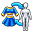 | Partial Set: choose which items to put on, which associated properties to apply, and what to do with items the figure is already wearing.
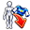 | Remove all items belonging to this outfit from the character.
 | Indicates that the selected figure is currently wearing this outfit.
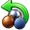 | Restore the materials of this outfit’s items if they have been changed. To make this option available, turn Save Materials on for each relevant item.
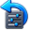 | Restore the properties associated with this outfit.
 | Restore the hand poses associated with this outfit.
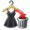 | Delete the outfit.

Register All Matches
When applying an outfit, Wardrobe may find unregistered objects already attached to the selected figure whose labels match saved outfit items, including automatically numbered labels. The Possible Matching Item dialog lists the proposed pairs. Similar names alone do not establish that they are the same items.
Choose Register All Matches only after confirming that every listed scene object is the corresponding saved item. WM2 checks the complete batch for matching parts and links before adding registration tags, then continues applying the outfit using the existing objects instead of loading additional copies. Saved item definitions are not overwritten. Ambiguous matches, different structures or conflicting registrations stop the operation with an explanation.
Continue leaves the objects unregistered and may load additional copies alongside them. Cancel leaves the matching objects unchanged. Registration is completed before the next application step: cancelling a later source-selection dialog does not remove successful registration tags. Save the scene after registration so the tags are retained when it is reopened.

Create and Edit Outfits

The button creates a new outfit. The icon next to an outfit opens it for editing.
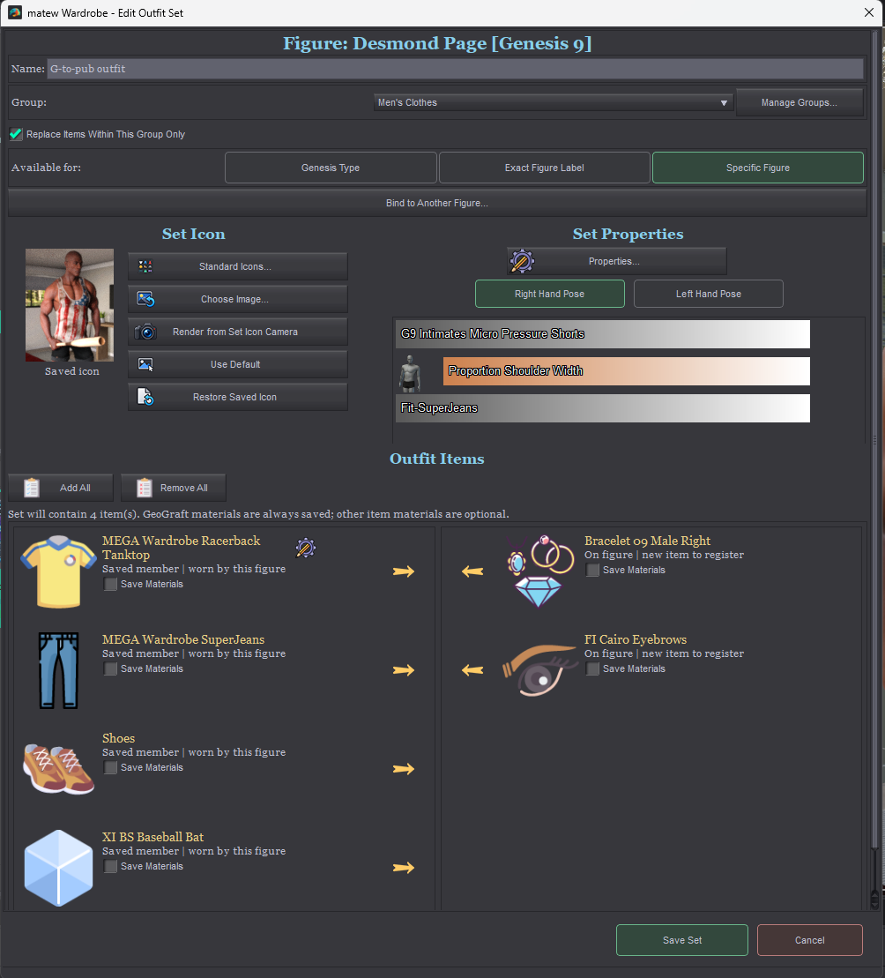
Group – lets you filter outfits in Wardrobe.
Manage Groups opens the group editor.
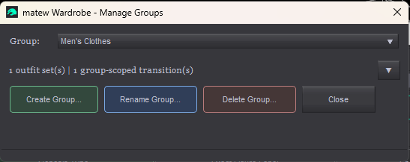
Replace Items Within This Group Only protects outfits in other groups. When switching between different groups, the old outfit is eligible for removal only if this option is unchecked for both the old and new outfits. If either outfit has it checked, the other group’s items and associated property values remain. Outfits in the same group follow the normal replacement behavior. Individual transition rules still apply unless you use a modifier-key override (see Outfit Panel).

Available For:
Value | Description
Genesis Type | The outfit is available for any figure of the same Genesis generation.
Exact Figure Label | Available only for figures with the specified label. Automatic numbering is supported: Helen, Helen (2), Helen (3), and so on.
Specific Figure | Available only for this specific character. Save the figure as a Scene Subset to use it in other scenes.

Using Specific Figure Sets in Other Scenes
When the first outfit is successfully saved for a figure, WM2 assigns the figure a persistent ID if it does not already have one. Outfits saved with Available For set to Specific Figure are linked to that ID, rather than to the figure's label.
After this first registration, save the figure as a Scene Subset to preserve its ID for use in other scenes. Load that saved subset when you want the same character in another scene. Saving the complete scene also preserves the registration, but a Scene Subset is convenient for reusing the character independently.
The figure loaded from that subset can access all outfits linked to its ID in the active WM2 library, including outfits created after the subset was saved. You do not need to save the subset again after each new outfit. The subset stores the figure identity; the outfits and their files remain in the library, which must still be available and selected in Wardrobe Settings.
Do not load multiple copies of the same registered figure into one scene: they carry the same ID, which causes a registration conflict. For an independent second character, load a fresh figure and use Set Maintenance > Attach Selected > Duplicate to create outfits bound to it. Save the newly registered figure as its own Scene Subset.

Bind to Another Figure
Available when Available For is set to Specific Figure. Creates a duplicate of the outfit bound to another character. This also allows outfits to be transferred between different figure types.
The figure picker lists characters currently in the scene. Figures of the same type appear dark green (light green when selected); other types appear orange (light orange when selected).
Binding to another Genesis type is allowed after a warning. The duplicate has its saved property overrides and hand poses removed because they may not be compatible with the target figure. The original outfit remains unchanged. Binding does not dress the target figure or move any clothing; DAZ Studio handles clothing fitting when you later apply the duplicate.
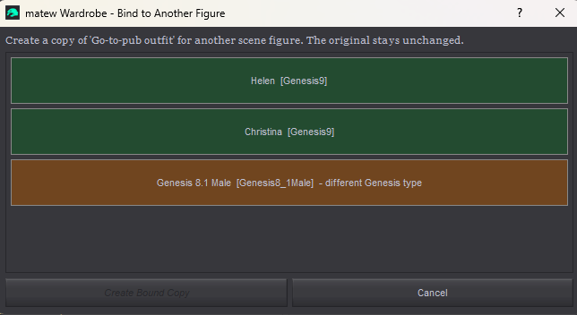

Set Icon
You can assign an outfit icon using the following options:
Button | Description
Standard Icons | Choose one of the standard icons.
Choose Image | Load an icon image from disk. Selecting an image already in this library’s outfit-icon folder reuses the existing file without creating another copy.
Create Set Icon Camera | Create a camera configured for a 100 x 125 px outfit icon render.
Render From Set Icon Camera | Render the outfit icon through the previously created camera using the current render settings. This option appears after the required camera has been created.
Use Default | Clear the current icon and use the default icon.
Restore Saved Icon | Restore the previously saved icon after making changes.
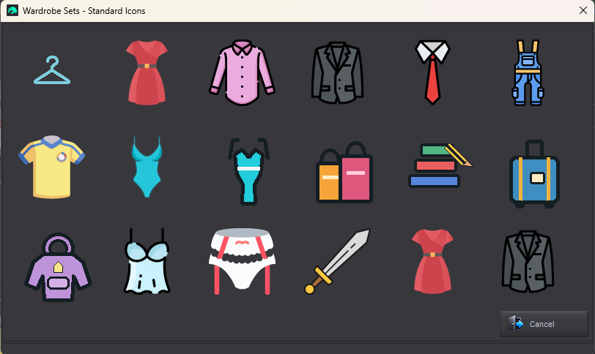

Set Properties
When applying certain assets, you may also need to set properties on the figure, such as Fiber Micropressure, or on the wearable items themselves, such as the Fit to Pants property of a T-shirt.
Wardrobe lets you do this. The selected properties are applied when you put on the outfit and reset when you take it off.
Right Hand Pose and Left Hand Pose – choose whether to save each hand pose with the outfit. This is useful for outfits that include handheld items, such as weapons.
Properties opens the editor for properties that change with the outfit. You can include properties of the figure itself or of any item in the outfit.
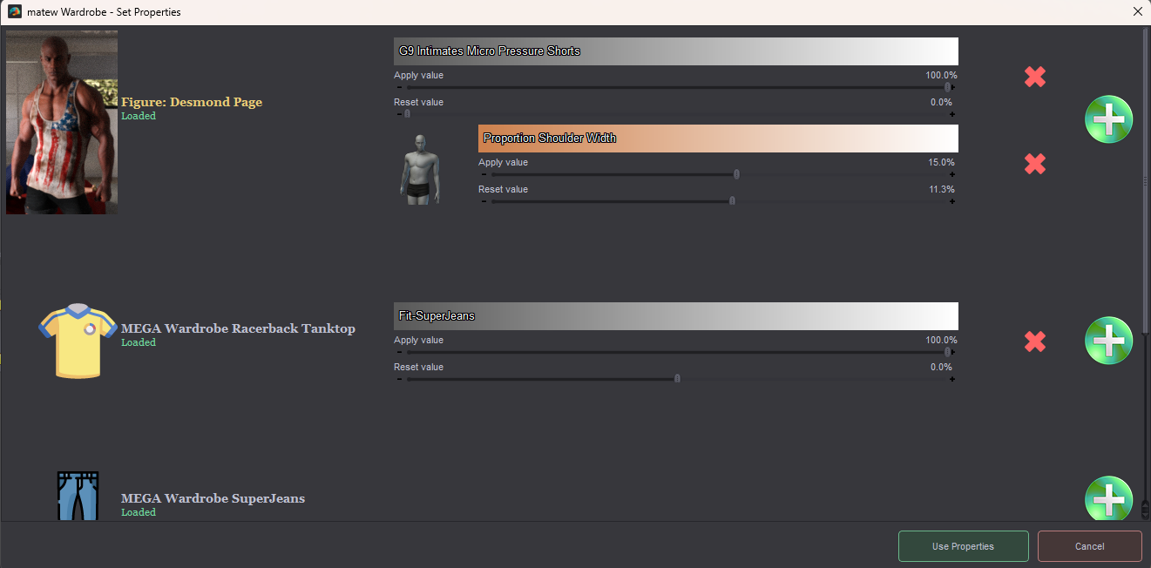
Value on apply – the value assigned to the property when the outfit is applied. Initially, this is the property’s current value if it differs from its default; otherwise, it is the property’s native maximum. You can edit this value.
Value on reset – the value restored when the outfit is removed. This is usually the property’s default value.
A saved property that is missing from a loaded figure or item is highlighted in red. Remove it or replace it through Properties. An unavailable property is skipped with a warning during application; it does not, by itself, stop the clothing from being applied. Wardrobe stays open so you can review Last Report. A custom morph must be saved and available on the figure to be found again after reloading the scene.

Outfit Items
The right side lists the items included in the outfit.
The left side lists items parented to the figure that are not included in this outfit.
Save Materials controls whether the item’s materials are saved. Enable it only if you plan to use the same item in different outfits with different materials.
Some items, such as geografts, do not have a Save Materials option. Their materials are saved automatically because they are required to restore the materials of the figure’s associated geoshells correctly.
When you add geografts to an outfit, the materials of all surfaces are saved as they are when the outfit is created. This allows the materials of geoshells present on the figure at that time to be restored correctly, even if those geoshells are not included in the new outfit. However, if you later add a geoshell that was not present when the outfit was created, Wardrobe cannot assign the correct materials to its new surfaces because those materials were never saved.


Wardrobe
Move one or more items into the wardrobe or back onto the character independently of any outfit. You can also assign individual transition rules or unregister an item. Moving an item into the wardrobe clears its Fit To relationship and moves it into a separate hidden group in the Scene pane.
You can delete the wardrobe group. Items will then be loaded from the library saved on disk.
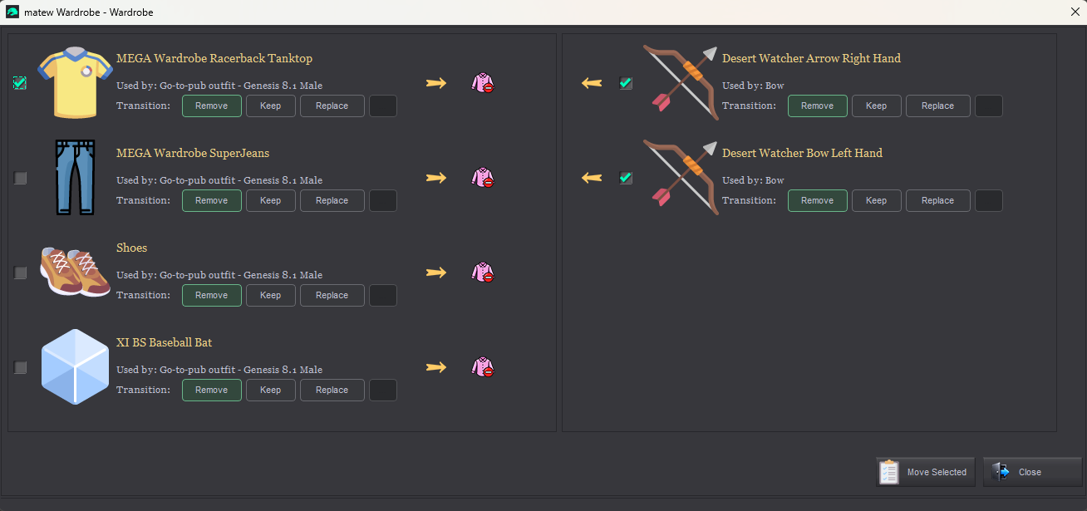
The left side shows items worn by the character. The right side shows items loaded in the scene but stored in the character’s wardrobe.
Use the arrows to move items in either direction one at a time, or select several items and click Move Selected to move them together.

Individual transition rules
Button | Description
Remove | The default behavior. The item is removed when you change outfits.
Keep | The item stays on the figure when you change outfits. It can only be removed manually.
Replace | The item is removed only if the new outfit contains a replacement item. Define the list of replacements here by choosing from any registered items.
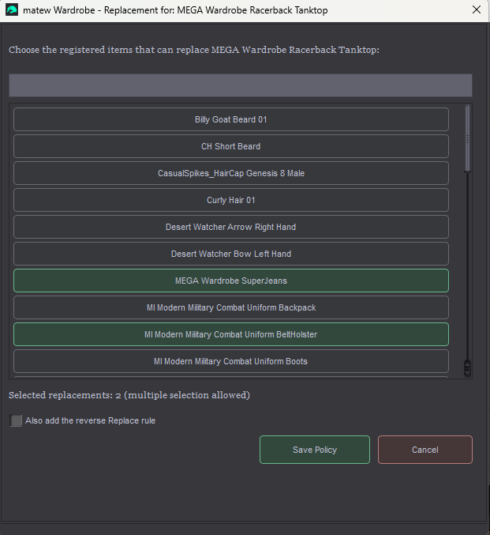
Unregister – removes the item’s registration. Wardrobe will no longer remove the item or move it into the wardrobe. You can unregister an item only if it is not included in any existing outfit.


Take Off All
Remove all registered items, regardless of their group or individual transition rules.


Settings
Settings opens on first launch. You can open it again using the button in the lower-left corner of the dialog.
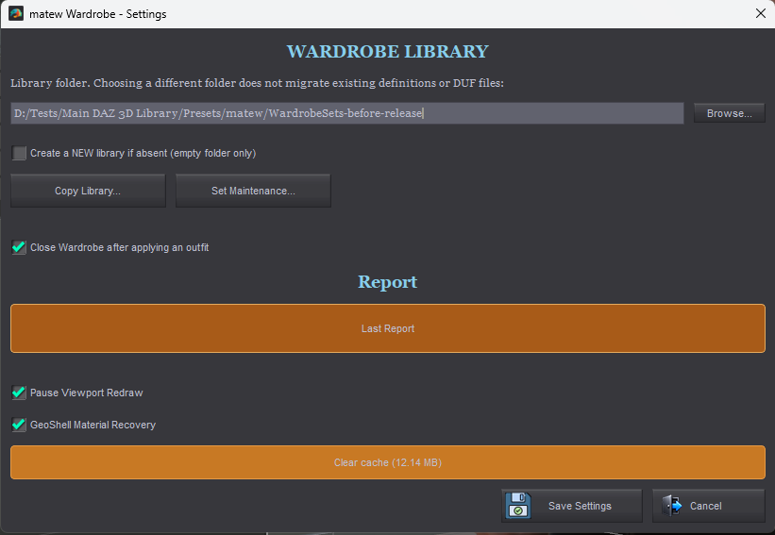
Before you begin, choose a folder in which to store the library.
Copy Library – create a verified backup copy of the active library in an existing empty folder. The copy is checked against the source. This does not switch the active library to the backup folder.
Close Wardrobe after applying an outfit – enabled by default. Wardrobe closes after an outfit is applied successfully without warnings or errors. Hold Alt when applying an outfit to reverse the setting for that click. If a warning or error occurs, the dialog stays open.
Pause Viewport Redraw – suspend viewport redraws while wearables are being moved. This speeds up the process slightly.
Geoshell Material Recovery – enable the advanced material recovery system when moving geografts and geoshells. If you are unsure whether you need it, leave it off. Wardrobe will prompt you to enable it when it is needed.
Report appears only when a report is available. Use the orange Last Report button to review the most recent operation report, including warnings and errors. The last saved report can also be opened after reopening Wardrobe. If you encounter a bug, please review the report and send it to me so I can investigate.

Set Maintenance
Open Set Maintenance from Settings to view all outfits in the active library, including those not available to the selected figure. Each entry shows its icon, a larger yellow name, its availability or owner, and its creation date and time in dd-MM-yyyy, hh:mm:ss format. Label-based availability is shown as examples such as "Fred 8.1, Fred 8.1 (2)...".
Filter by name narrows the list as you type, ignoring letter case. Select entries with their icons or checkboxes. Select All selects only the matching visible entries; outfits hidden by a filter change are deselected. Unselect All clears the current selection. The total library folder size in MB appears before the selected/total set counts.
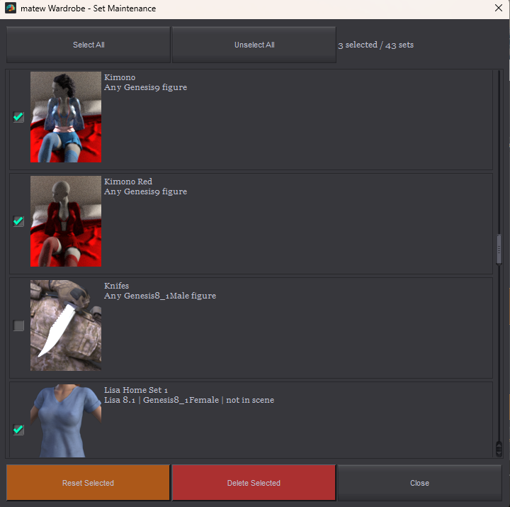
Reset Selected (orange) – remove the Specific Figure or Exact Figure Label restriction from selected outfits, making them available to any figure of their saved type. Use this when an outfit’s original figure is no longer available. The outfit contents are kept.
Attach Selected (orange) binds the selected outfits to the figure currently selected in Wardrobe. First choose Move to change the existing outfits, or Duplicate to create copies while keeping the originals. Review the target figure and number of outfits, then confirm. Neither option applies clothing or moves scene objects.
Copies receive new IDs, creation dates and names based on the original outfit and the target figure. Move keeps the existing outfit names, IDs and creation dates. Outfits of the same Genesis type retain their saved properties and hand poses.
Transferring to a different Genesis type requires confirmation. If the affected outfits contain saved properties or hand poses, the confirmation identifies this. Move permanently removes these incompatible settings and warns that this cannot be undone. Duplicate omits them only from the copies; the originals keep all saved data. DAZ Studio fits clothing when the transferred outfits are later applied.
Delete Selected (red) collects unused library-owned outfit files and shows the number of outfits, the number of files, and the space to be freed in MB before deletion. The confirmation warns that deletion is irreversible. Click the red Delete button to remove the selected definitions and eligible unused files. Files still needed by other outfits or recovery records are preserved. Scene objects are kept. There is no extra completion dialog.

Material Backup Cache
Clear cache in Settings displays the size of material recovery backups created by the basic Wearables Manager scripts. Cache empty means there are no backups to clear; Cache unavailable means the cache could not be checked. These backups are separate from the Wardrobe outfit library.
Before clearing the cache, return all stored items to their owners and restore their GeoShell materials in every scene that may use these backups, including saved scenes that are not currently open. The script checks only the current scene and blocks cleanup if it still needs material recovery.
Other saved scenes and Undo/Redo history may still reference these backups. Deleting them can permanently remove the ability to restore those materials, and cache deletion cannot be undone. Leave the cache in place if you are unsure whether it is still needed.
Clearing the cache does not delete Wardrobe library materials, saved outfits or presets. The displayed size updates after cleanup.

Technical Script for Developers
Wearable Manager Service.dse lets developers integrate WM2 with their own scripts and products, including commercial products. Written notification to the author is not required.
WM2 must be installed and its Wardrobe library configured. Keep the service beside Wearable Manager Wardrobe.dse. Resolve its installed path in your product and close other WM2 or Wardrobe dialogs before calling it.
Call DzScript.execute([characterLabel, outfitNameOrID, action, output]). The first three arguments are strings; output is a DzSettings instance used to receive the result.
1. characterLabel: the exact scene figure label, including any numbered suffix such as "Helen (2)". An empty string uses the primary selected supported figure or the figure owning the primary selected bone.
2. outfitNameOrID: an empty string for list sets; an exact outfit name for put on or take off; a returned set ID for put on by id or take off by id.
3. action: "list sets", "put on", "take off", "put on by id", or "take off by id". Action names ignore letter case and surrounding spaces.
4. output: a DzSettings result container. This is required for list sets and recommended for all calls. Existing three-string put on/take off calls remain supported.

Available outfits and results
list sets reads all outfits available to the target figure, regardless of the main dialog's search or group filters. It respects Genesis type, label matching including numbered copies, and Specific Figure bindings. It does not change clothing, tag figures, or change the selection. An empty list is a successful result.
After execute() returns true, read output.getStringValue("result") and parse it with JSON.parse(). The JSON contains apiVersion, ok, action, libraryID and figure (label and type). List results also contain sets: an array of objects with id, name, groupID and groupName. Entries are sorted by name; the implicit Default group has an empty ID.
Use returned IDs for actions so duplicate or renamed outfit names are handled reliably. IDs belong to a library: refresh the list after the library, target figure or its selection changes, or after an outfit is deleted or rebound. Listing confirms availability; file and property checks still run when the outfit is applied.
Successful action results include set (id and name), reportPath, warningCount and warnings. execute() returns false on failure; read errorMessage() and do not use an earlier result. Non-fatal warnings can accompany success. Do not rely on DzScript.result() for DAZ 6; use the DzSettings container.

Calling the service
Use this helper after resolving servicePath to the installed Wearable Manager Service.dse file:
function callWM2(servicePath, character, outfit, action) {
var service = new DzScript();
var output = new DzSettings();
try {
if (!service.loadFromFile(servicePath))
throw new Error(service.errorMessage());
if (!service.execute([character, outfit, action, output]))
throw new Error(service.errorMessage());
return JSON.parse(String(output.getStringValue("result")));
} finally {
service.deleteLater();
output.deleteLater();
}
}
var available = callWM2(servicePath, "", "", "list sets");
Display available.sets in your product's outfit picker. After the user chooses an entry, pass its ID to put on by id or take off by id:
var result = callWM2(servicePath, "", chosen.id, "put on by id");
// To remove the selected outfit instead:
// callWM2(servicePath, "", chosen.id, "take off by id");
Put on follows the saved group replacement and compatibility rules. Take off stores the worn members of that outfit and follows the existing property and hand-pose reset rules. It does not delete clothing. If no members of the outfit are worn, it returns an error.
Unknown or ambiguous figure labels, unsupported selections, missing or incompatible outfits, and ambiguous outfit names cause an error instead of choosing a match arbitrarily. ID-based calls avoid outfit-name ambiguity.
The service uses the active Wardrobe library and operational preferences. It opens no main window or final success dialog. Keyboard modifiers and the Close Wardrobe preference do not affect calls. Native import, AutoFit or required safety dialogs can still appear; this is not an unattended batch interface.
Scene operations use Wardrobe's verification, rollback and Undo handling. The service does not create a library or save the scene automatically. The report location is also printed to the DAZ log.

Known issues

Tested in DAZ 3D Studio 4.24 and DAZ 3D Studio 6.25. Some issues may not appear in later versions.
- When Using Scene Manager by AuraVix Studio v. 1.0.0.8 or earlier, Invoke dForce crashes in the end of simulation if integration with Wearables Manager is on. This issue was fixed in v. 1.0.0.9.
Solution: update Scene Manager by AuraVix Studio to the latest version.
- Parameters Panel Initialization: DAZ 3D Studio may crash when you use Wearables Manager Menu to navigate through Parameters Panel if you haven’t used Parameters Panel at least once manually. DAZ Script does not explicitly support navigation on the Parameters Panel, which likely causes the issue.
Solution: Click on the Parameters Panel upon starting DAZ 3D to initialize it. If the panel is visible at startup, it is already initialized.
- Surfaces Panel Navigation: the same thing may happen if you’re navigating on Surfaces Panel using Wearables Manager Menu without prior using of the Surfaces Panel manually.
Solution: Click on the Surfaces Panel upon starting DAZ 3D to initialize it. If the panel is visible at startup, it is already initialized.

